D
G
F
E
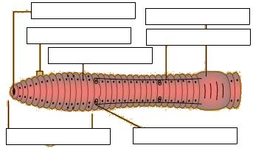
C
B
A
Worm - External Anatomy View
Labels – anterior end, clitellum, mouth, segment, setae, sperm duct openings, sperm grooves

C
D
B
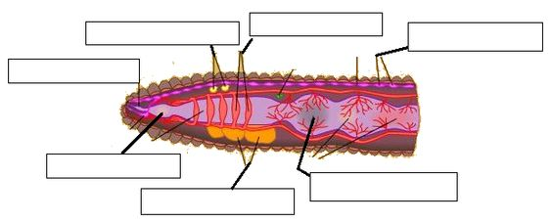
M
K
I
H
E
L
J
A
G
F
Worm – Internal Anatomy View
Labels – aortic arches, brain, crop, esophagus, ganglia, gizzard, intestine, mouth cavity, nephridia, pharynx, seminal receptacles, seminal vesicles, ventral nerve cord

