Comparison - Mount St. Helens and Nyiragongo 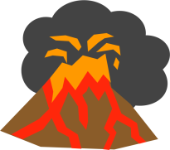
Draw a large Venn Diagram to compare and contrast the eruptions of Mount St. Helens and Nyiragongo . Label each part of the diagram. Add art work.
M.t St. Helens Nyiragongo
(Venn Diagram)
Write the features unique to either group in the larger areas; note features they share in the overlap area in the center of the diagram.
Research both volcanoes for information relating to these features:
- Located near a convergent plate boundary
- Located near an early-stage divergent plate boundary
- Produced significant lava flows
- Eruption followed a century of inactivity
- Several eruptions in the last century
- Few monitoring instruments prior to unrest
- Volcanic gases released prior to main eruption
- Frequent earthquakes associated with unrest
- Unrest lasted for approximately 2 months before eruption
- Eruption occurred in daylight
- Volcano located within 20 kilometers (12 miles) of large city
- Volcanic activity subsided after about 1 week
- Low-viscosity magma
- USGS geologists aided in interpretation of volcanic activity
- Death toll less than 100
- Death toll more than 100
- Shape of volcano changed prior to eruption
- Eruption characterized by a massive lateral blast

