1. Students were performing a binary mix lab and created the following table to show their observations when mixing the different solutions. They marked NR when they did not see a precipitate and PPT when a precipitate was formed.

|  |  |  |  |  |
| --- | --- | --- | --- | --- |
|  | **Sr(NO3)2** | **NaCl** | **KOH** | **Pb(SO4)2** |
| **Sr(NO3)2** | NR | NR | NR | PPT |
| **NaCl** | NR | NR | NR | PPT |
| **KOH** | NR | NR | NR | PPT |
| **Pb(SO4)2** | PPT | PPT | PPT | NR |

Which of the following statements is true about the information from the table?

* 1. Sr(NO3)2 only produced a precipitate when reacting with KOH.
  2. KOH never produced a precipitate when mixed with another chemical.
  3. Pb(SO4)2 produced a precipitate with KOH, NaCl, and Sr(NO3)2.
  4. NaCl always produced a precipitate.

**C.10.B-R / C.2.I**

1. The solubility of KCl(s) in water depends on the-
2. pressure on the solution
3. rate of stirring
4. size of the KCl sample
5. temperature of the water

**C.10.F-R**



1. The above picture shows a light bulb connected to a battery with the circuit interrupted by a solution. When dissolved in the water to form a 1.0 molar solution, all of the following substances will complete a circuit allowing the bulb to light ***except****-*
   1. hydrochloric acid.
   2. sodium nitrate.
   3. sucrose.
   4. ammonium sulfate.

**C.10.E –R/C.2.I**

1. Which best explains why water dissolves most salts?
2. Water is polar, and salts form ions in solution.
3. Water is nonpolar and salts form ions in solution.
4. Water has the same density as salts.
5. Water has different density than salts

**C.10.A-S**

1. A technician prepared a solution by heating 100 milliliters of distilled water while adding KCl crystals until no more KCl would dissolve. She then capped the clear solution and set it aside on the lab bench. After several hours she noticed the solution had become cloudy and some solid had settled to the bottom of the flask. Which statement *best* describes what happened?
   1. As the solution cooled, evaporation of water increased the KCl concentration beyond its solubility.
   2. Water molecules, trapped with the KCl crystals, were released after heating.
   3. At lower temperatures the solubility of the KCl decreased and recrystallization occurred.
   4. At increased temperatures the solubility of KCl increased and remained too high after cooling.

**C.10.E-R/C.2.I**

1. Power plants that discharge warm water into rivers have a negative effect on aquatic life. This is because the higher water temperature —
2. increases the pressure of the river water
3. increases the pH value of the river water
4. decreases sediment solubility in the river water
5. decreases the dissolved oxygen in the river water

**C.10.F-R**

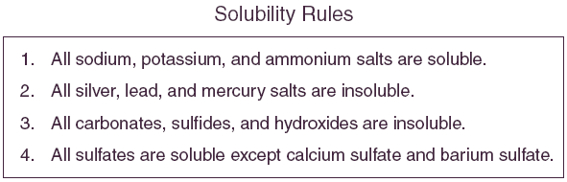

1. Which of the following salts has the greatest solubility in water at 25°C?
   1. CaCO3
   2. FeS
   3. HgCl2
   4. KClO4

**C.10.B/C.2.H**

1. Acids and bases have either more Hydroxide ions or more Hydrogen ions. The concentration found in water is:
2. [H+] >[OH-]
3. [H+] <[OH-]
4. [H+] =[OH-]
5. [H+]x[OH-]

**C.10.A-S**

1. Which of the following solutions will form a precipitate when mixed with LiCl?
   1. KNO3
   2. AgClO3
   3. MgI2
   4. Na3PO4

**C.10.B-R**

1. A water strider is able to walk on water because of water’s
2. Polarity.
3. Ability to dissolve many substances.
4. High surface tension.
5. Density

**C.10.A-S**



1. The table shows that the amount of sodium nitrate that can be dissolved in water-
2. increases as the temperature increases.
3. increases as the surface area of molecules of sodium nitrate increases.
4. decreases as the molarity increases.
5. decreases as the pressure increases.

**C.10.F-R**

1. How many liters of a 4.00 M Na2CO3 solution are need to make .5 L of 1.0 M Na2CO3 solution?

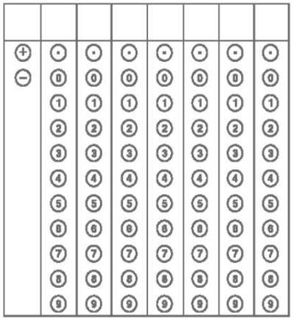

**C.10.D-S**

1. Which compound is an electrolyte?
2. butene
3. dimethyl ether
4. propane
5. methanoic acid

**C.10.E-R**

1. How many grams of KCl are necessary to prepare 1.50 liters of a 0.500-*M* solution of KCl?
2. 224 g
3. 74.6 g
4. 56.0 g
5. 24.9 g

**D.10.C-S**

1. Which pair of solutions will produce a precipitate when they are mixed?
2. calcium chloride and sodium sulfate
3. magnesium sulfate and zinc (II) nitrate
4. sodium phosphate and lithium chloride
5. lead (II) nitrate and potassium phosphate

**C.10.B-R**



1. The table shows temperature and pressure in four containers holding the same amount of water. According to the table, in which container can the most sodium chloride be dissolved in the water?
   1. Q
   2. R
   3. S
   4. T

**C.10.F-R/C.2.I**

1. A student weighs 5.0 g of sodium fluoride, molar mass 42 g, and dissolves it enough water to fill a 250 mL flask. What is the concentration of the solution?
2. 0.06 *M*
3. 0.10 *M*
4. 0.12 *M*
5. 0.48 *M*

**C.10.C-S**

1. If 250.0 mL of a 0.96 M solution of acetic acid C2H4O­2 are diluted to 800.0 mL, what will be the approximate molarity of the final solution?
   1. 0.19 M
   2. 0.24 M
   3. 0.30 M
   4. 0.77 M

**C.10.D-S**

1. According to the following information from a laboratory investigation, which statement is correct?

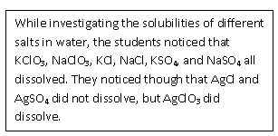

1. All silver compounds are insoluble.
2. Sulfates compounds never dissolve.
3. Compounds with potassium, sodium and chlorate always dissolve.
4. Chloride compounds always dissolve.

**C.10.B-R/ C.2.I**

1. A solution that contains **less** solute than it can hold at a given temperature is-
2. dissociated.
3. saturated.
4. supersaturated.
5. unsaturated.

**C.10.E-R**

Unit 8 Aqueous Systems and Solutions Common Assessment Answer Key

|  |  |  |  |  |
| --- | --- | --- | --- | --- |
| **Item Number** | **Correct Answer** | **Readiness or Supporting** | **Content Student Expectation** | **Process Student Expectation** |
| 1 | C | R | C.10.B | C.2.I |
| 2 | J | R | C.10.F |  |
| 3 | C | R | C.10.E | C.2.I |
| 4 | F | S | C.10.A |  |
| 5 | C | R | C.10.E | C.2.I |
| 6 | J | R | C.10.F |  |
| 7 | D | R | C.10.B | C.2.H |
| 8 | H | S | C.10.A |  |
| 9 | B | R | C.10.B |  |
| 10 | H | S | C.10.A |  |
| 11 | A | R | C.10.F |  |
| 12 | 0.125 | S | C.10.D |  |
| 13 | J | R | C.10.E |  |
| 14 | B | S | C.10.C |  |
| 15 | J | R | C.10.B |  |
| 16 | D | R | C.10.F | C.2.I |
| 17 | J | S | C.10.C |  |
| 18 | C | S | C.10.D |  |
| 19 | H | R | C.10.B | C.2.I |
| 20 | D | R | C.10.E |  |