Unit 5.3: Chemical Bonding – Types of Bonds
There are three main types of Chemical bonding.
___________, _________________, ___________________

Ionic Bonding occurs when there is a _______________ of electrons.

Covalent Bonding occurs when atoms ___________ electrons.

Metallic Bonding consist of the attraction of free __________ valance electrons for positively charged __________ ions.

Electro ____________ are used to determine what type of ________ is formed when atoms come together in a chemical reaction.

To find the type of __________, find the _________________ in the electro negativities.

If the difference is _______________ than 1.67 an ________ bond is formed.
If the difference is _________ than 1.67 a _________ bond is formed.

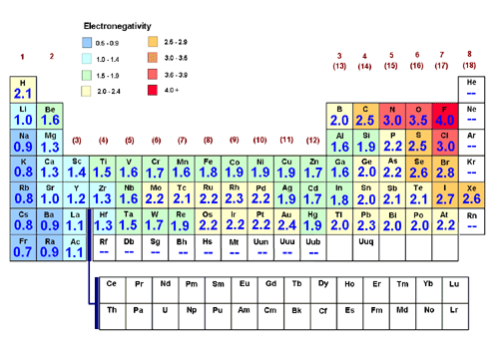

Rules for Ionc Bonding
All atoms want to obtain eight electrons in the valence energy level. To do so they will give, take, or share electrons.
NaCl Sodium Chloride: Sodium: (_____) Chlorine: (_____)

Na: 1s²2s²2p⁶_____ Cl: 1s²2s²2p⁶3s²3p⁵

Sodium transfers the 3s¹ to Chlorine to complete the 3p⁵ energy level.
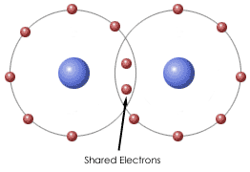
The electronegativity ___________ is 1.72
An __________________________ bond is formed.

Covalent Bonding:
- The element with the fewest atoms goes in the _________________________.
- The other atoms go around the ____________________________ atom.
- Show the transfer of the electrons with a _______________________________ for
the atom that ________________ the electrons and a ________________ for the atoms that gain the electrons.
AsI₃ Arsenic Triiodide Arsenic (________) Iodine (_______)
As: 1s²2s²2p⁶3s²3p⁶4s²3d¹⁰4p³ I: 1s²2s²2p⁶3s²3p⁶4s²3d¹⁰4p⁶5s²4d¹⁰5p⁶4d¹⁰5p⁵
The electro negativity difference is _________________________________
A _________________________ bond is formed. The atoms share the electrons.
Rules for Showing Covalent Bonds
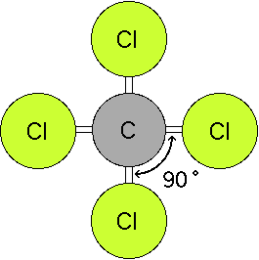
- The element with the _______________________________ atoms goes in the center.
- The other elements go around the __________________ atom.
- A bonding pair can only form where there is an __________ electron.
- Shared pairs or bonding pairs are shown with a ________. One dash equals __________ electrons.

