1. Which of the following is the correct Lewis electron-dot diagram for the sodium atom?
   1. 
   2. 
   3. 
   4. 

**C.6.E – R/2.I – P**

1. The shell model of Chlorine, Cl, is shown below.

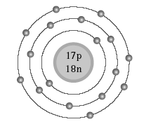

What is the electron configuration for Chlorine, Cl?

1. 1s22s22p53s23p7
2. 1s22s22p63s23p5
3. 1s22s22p63s23p54s5
4. 1s22s22p63s23p44s2

**C.6.E – R/2.I - P**

1. The alkali metals are located in which group of the periodic table?
   1. 1
   2. 2
   3. 3
   4. 4

**C.5.B – R**

1. Below is a version of the Periodic Table created by Dmitri Mendeleyev. By which physical property did he organize the table?

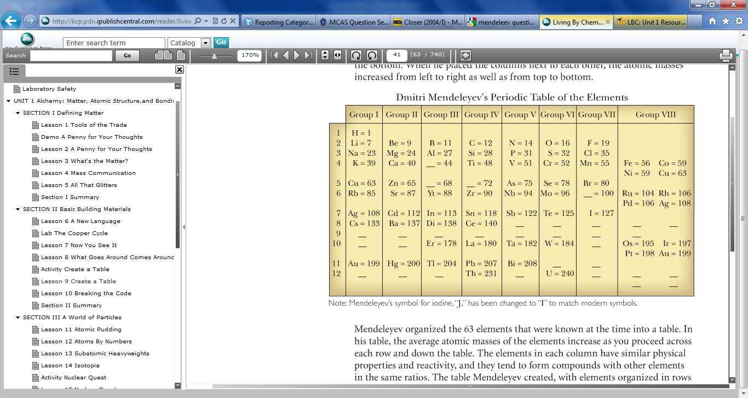

1. Increasing density from left to right
2. Decreasing charge from left to right
3. Increasing atomic mass from top to bottom
4. Increasing reactivity from bottom to top

**C.5.A – S/2.I – P**

1. Calcium is a metal. On the periodic table, calcium is in Group 2 and Period 4. Which of the following elements is most likely to have similar properties as calcium?
   1. scandium, in Group 3 and Period 4
   2. potassium, in Group 1 and Period 4
   3. aluminum, in Group 13 and Period 3
   4. magnesium, in Group 2 and Period 3

**C.5.B – R**

1. What is the electron configuration of sulfur?
2. 1s22s22p63s23p3
3. 1s22s22p63s23p4
4. 1s22s22p63s23p5
5. 1s22s22p63s23p6

**C.6.E – R**

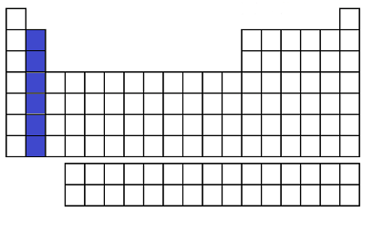

1. What is the name of the chemical family shown in the shaded region on the periodic table?
   1. Halogens
   2. Noble Gases
   3. Alkaline Earth Metals
   4. Transition metals

**C.5.B – R/2.I – P**

1. An unidentified element has many of the same physical and chemical properties as magnesium and strontium but has a lower atomic mass than either of these elements. What is the most likely identity of this element?
2. Sodium
3. Beryllium
4. Calcium
5. Rubidium

**C.5.B – R**

1. Why did scientists accept the periodic table as a useful way to organize information about the elements?
   1. Mendeleev was a well respected scientist.
   2. The table was demonstrated to have predictive value.
   3. There was no other way to organize the information, and so chemists used the table.
   4. The description of atomic structure was presented better in the table than in other tools.

**C.5.A – S**

1. In the periodic table created by Dmitri Mendeleyev, it is organized by Groups which have the same number of valence electrons and similar bonding characteristics. Mendeleyev used what kind of properties to organize the table?
2. Chemical
3. Physical
4. Colligative
5. Both F and G

**C.5.A – S**

1. Which of the following atoms can have the lewis valence electron dot structure shown below?



* 1. Helium
  2. Nitrogen
  3. Carbon
  4. Aluminum

**C.6.E – R/2.I – P**

1. Why is cobalt (Co) placed before nickel (Ni) on the periodic table of the elements even though it has a higher average atomic mass than nickel?
2. Nickel has one more proton.
3. Cobalt was discovered first.
4. Nickel has fewer electrons.
5. Cobalt has a lower density.

**C.5.B – R**

1. How did Mendeleev decide which elements should be placed in the same group of the periodic table?
   1. He grouped elements with similar chemical and physical properties.
   2. He grouped together elements with the same number of valence electrons.
   3. He ordered the elements by atomic number and the pattern appeared.
   4. He arranged the elements across the table from most reactive to least reactive.

**C.5.A – S**

1. Which of the following elements has the same Lewis dot structure as silicon, Si?
2. germanium, Ge
3. aluminum, Al
4. arsenic, As
5. gallium, Ga

**C.6.E – R**

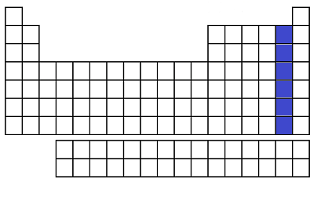

1. The above periodic table shows a shaded region on the periodic table. What is the name of chemical family being shown?
   1. Chalogens
   2. Alkali Metals
   3. Noble Gases
   4. Halogens

**C.5.B – R/2.I – P**

1. What element has the electron configuration 1s22s22p63s23p2?
2. nitrogen
3. selenium
4. silicon
5. silver

**C.6.E – R**

1. Consider the spectrum for the hydrogen atom. In which situation will light be produced?
   1. Electrons absorb energy as they move to an excited state.
   2. Electrons release energy as they move to an excited state.
   3. Electrons absorb energy as they return to the ground state.
   4. Electrons release energy as they return to the ground state.

**C.6.B-S**

1. What is the approximate energy of a photon having a frequency of 4 x 107 Hz?

(h = 6.6 x 10-34 Js)

1. 3 x 10 -26 J
2. 3 x 10 -27 J
3. 2 x 10 -41 J
4. 3 x 10 -42 J

**C.6.C-S /** **C.2.G-Process**

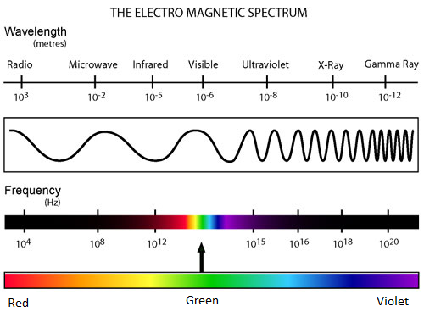

1. Using the above labeled Electromagnetic Spectrum drawing, which statement regarding red and green visible light is correct?
   1. The speed of green light is greater than that of red light.
   2. The wavelength of green light is longer than that of red light.
   3. The energy of green light is lower than that of red light.
   4. The frequency of green light is higher than that of red light.

**C.6.B-S / C.2.I-Process**

1. Calculate the approximate frequency of a photon having an energy 5 x 10-24 J?
   1. 8 x 109 Hz
   2. 3 x 10-57 Hz
   3. 3 x 10-58 Hz
2. 1 x 10-10 Hz

**C.6.C-S /** **C.2.G-Process**

Unit 3 Periodic Table and Electrons in the Atom Common Assessment Answer Key

|  |  |  |  |  |
| --- | --- | --- | --- | --- |
| **Item Number** | **Correct Answer** | **Readiness or Supporting** | **Content Student Expectation** | **Process Student Expectation** |
| 1 | A | R | C.6.E | C.2.I |
| 2 | G | R | C.6.E | C.2.I |
| 3 | A | R | C.5.B |  |
| 4 | H | S | C.5.A | C.2.I |
| 5 | D | R | C.5.B |  |
| 6 | G | R | C.6.E |  |
| 7 | C | R | C.5.B | C.2.I |
| 8 | G | R | C.5.B |  |
| 9 | B | S | C.5.A |  |
| 10 | J | S | C.5.A |  |
| 11 | C | R | C.6.E | C.2.I |
| 12 | F | R | C.5.B |  |
| 13 | A | S | C.5.A |  |
| 14 | F | R | C.6.E |  |
| 15 | D | R | C.5.B | C.2.I |
| 16 | H | R | C.6.E |  |
| 17 | D | S | C.6.B |  |
| 18 | F | S | C.6.C | C.2.G |
| 19 | D | S | C.6.B | C.2.I |
| 20 | F | S | C.6.C | C.2.G |