***Energy and Light***

Classical View Of the Universe

* Matter has mass and volume.
* __________ is not composed of particles.
* Energy can only travel in **____________**.

The Nature of Light – Wave Nature

* Light is a form of **electromagnetic radiation**.
* Electromagnetic radiation is made of waves called __________; traveling at “c”
* Electromagnetic radiation moves through _________ like waves move across the surface of a pond

***Electromagnetic Waves***

* Every wave has four characteristics that determine its properties:
  + wave speed, v
  + height (___________________),
  + ______________________,
  + Frequency (number of wave peaks that pass in a given time) ƒ.
* All electromagnetic waves move through space at the same, constant speed.
  + 3.00 x 108 meters per second in a vacuum = **The speed of light, c**.

***Characterizing Waves***

* The **_________** is the height of the wave.
  + The distance from node to crest.
  + The amplitude is a measure of how ______________ the light is—the larger the amplitude, the _______________ the light.
* The **wavelength (λ)** is a measure of the distance covered by the wave.
  + The distance from one __________ to the next.
    - It is actually one full cycle, ______
  + Usually measured in nanometers.
    - 1 nm = 1 x 10-9 m
* The **______________ (ƒ)** is the number of waves that pass a point in a given period of time.
  + The number of waves = number of cycles.
  + Units are ________ (___), or cycles/s = s-1.
    - 1 Hz = 1 s-1
* The total _______ is proportional to the amplitude and frequency of the waves.
  + The larger the wave amplitude, the more force it has.
  + The more frequently the waves strike, the more ______________ force there is.

***The Electromagnetic Spectrum***

* The **electromagnetic spectrum** is the range of all possible frequencies of _______________________ ______________________ .
  + The color of the light is determined by its wavelength.
* The electromagnetic spectrum extends from low frequencies used for modern _____________ communication to gamma radiation at the short-wavelength (__________-___________________) end.

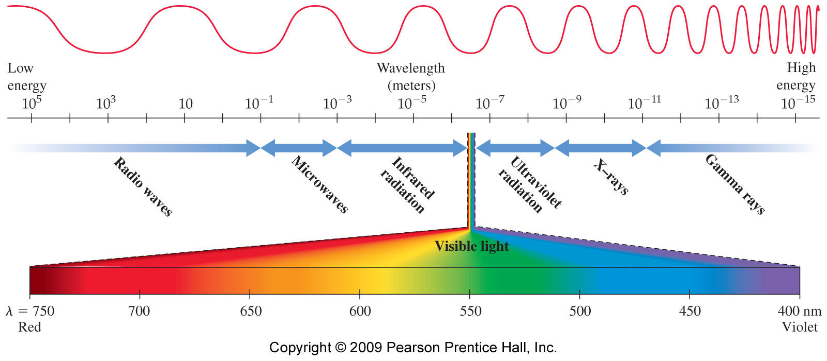

***The Electromagnetic Spectrum and Photon Energy***

* Short wavelength light have photons with _________________ = __________________
  + Radio wave photons have the lowest energy.
  + Gamma ray photons have the highest energy.
* ________-energy electromagnetic radiation can potentially damage biological molecules.
  + Ionizing radiation
  + The waves fit between atom-atom bonds and _____________________ the atoms loose.
* Order the Following Types of Electromagnetic Radiation:  
  Microwaves (MW), Gamma Rays (GR), Green Light (GL), Red Light (RL), Ultraviolet Light (UV)
  + By wavelength (short to long).
  + By frequency (low to high).
  + By energy (least to most).