***Isotopes***

* 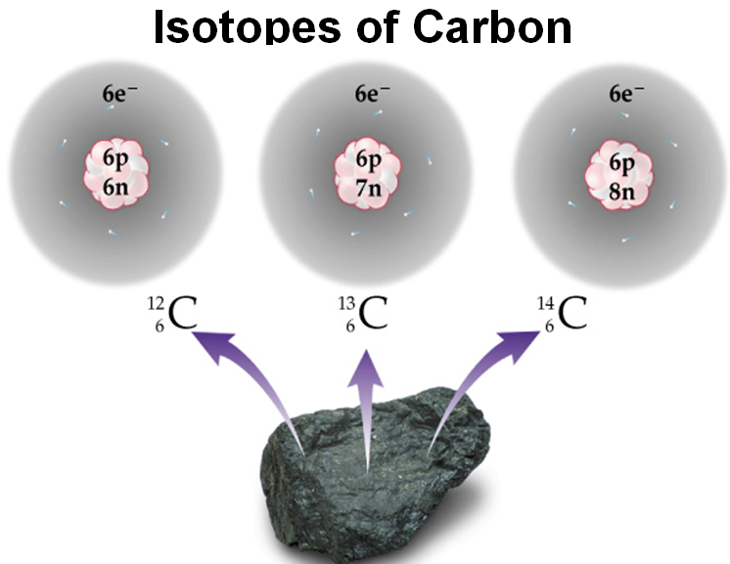Isotopes are atoms of the same element with different _______________.
  + Changing the number of ____________ and the mass number gives you different isotopes of the same type of atom.
    - Such as those of Carbon:
${}_{6}^{12}C$ ${}_{6}^{13}C$ ${}_{6}^{14}C$

* Calculate the protons, neutrons, and electrons in these isotopes of chlorine.

C:\Users\cpasilla\AppData\Local\Microsoft\Windows\Temporary Internet Files\Content.IE5\T2Z3W3O0\MC900226624[1].wmf chlorine - 35 chlorine - 37

* + Protons
  + Electrons
  + Neutrons

***Average Atomic Mass***

* Average atomic mass is based on all the ____________ of an element and their ______________ %.
  + Atomic mass is not a whole number … ________________________ is a whole number.
  + Weighted average = mass isotope 1 x (%) + mass isotope 2 x (%) + …….. 100 100

***Calculating Average Atomic Mass***

* **Isotopes Mass of Isotope Abundance**

24Mg = 24.0 amu 78.70%

25Mg = 25.0 amu 10.13%

26Mg = 26.0 amu 11.17%

In order to calculate average atomic mass, multiply each isotopes’ mass by the abundance (%/100). Then add all together to get the final atomic mass.

* Example: The mass of a Cu-63 atom is 62.94 amu, and that of a Cu-65 atom is 64.93 amu. The percent abundance of Cu-63 is 69.17% and the percent abundance of Cu-65 is 30.83%. What is the average atomic mass of Cu?