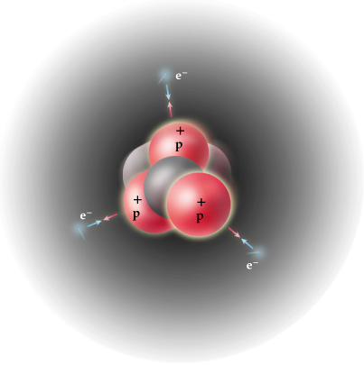
Proton
Electron
- It’s a particle located in the _____________ of an atom.
Neutron
- It has a charge of ___________ ___ and a mass of _____
amu (atomic mass units).
- ____________ are almost identical in size to neutrons.
The protons determine the ________________.
Proton
- The _______________ of protons will tell you what element
it is.
- An atom having 6 protons will always be Carbon, C.
- The atomic number is the same as the number of protons.

Electron
  - It’s a particle located _____________ the nucleus of an atom.
  - It has a charge of ____ and a mass of ___ amu (atomic mass units).
  - Electron are very small, they are ___________ the size of a proton.
- In a neutral atom, the number of _____________ is the same as the atomic number.
- If an atom becomes an _______, the number of electrons changes creating a charged atom.

Neutron
  - It’s a particle located _____ the nucleus of an atom.
  - It has a charge of ____ and a mass of ____ amu (atomic mass units).
  - Neutrons are almost identical in size to _____________.
- Number of neutrons depends on the ______________________.

Mass Number
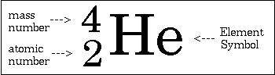
- Mass number is the number of ____________ plus _____________.
- Mass number is found by adding protons and neutrons.
  - 3 protons + 4 neutrons = 7 (Lithium)
- Or can be found by rounding atomic mass to the nearest ______________ number.
  - Iodine atomic mass is 126.9044 so its mass number is 127.
- Mass number can be used to calculate _______________ in an atom.
  - Iodine mass # 127 – Iodine atomic # 53 = 74 neutrons.
Calculating Particles in an Atom
