Atomic theory ---the idea that all matter is made up of _______________. It is a very old idea dating back to the ancient Greeks. Over time, scientists have come up with various models for the atom based on their observations. These atomic models have been ____________ and revise as new scientific evidence is discovered.
John Dalton (1803)
Dalton’s Postulates:
- Atoms can’t be subdivided (False)
- ___________________________________________
- Atoms aren’t ____________ or _________________ in chemical reactions
- All molecules of the same compound have the same composition
- Atoms combine in definite proportions to form compounds
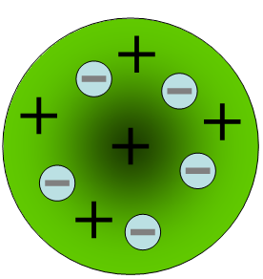
JJ Thompson (1897)
- Discovered ____________ charged particles with the cathode ray tube (electrons).
- Measured the charge to mass ratio of the electron
- Knew there had to be other ________________ in atoms (because of the mass).
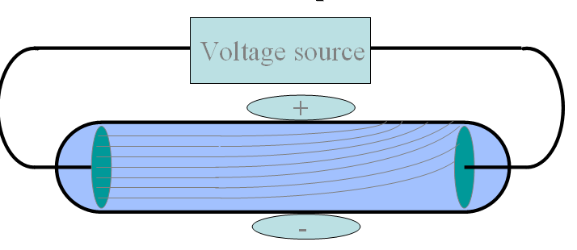
Cathode Ray Tube: Passing an electric current through the cathode makes a beam appear to move from the negative to the positive end. _______________ are negatively charged and are attracted to a positive magnetic source.
Ernest Rutherford (1911 &1918)
- Atom is mostly ___________ ____________ with a small, positive dense mass at center (______________) – 1911
- Rutherford is generally credited with the discovery of the ____________, though he was not able to isolate it from the _____________ within the nucleus.
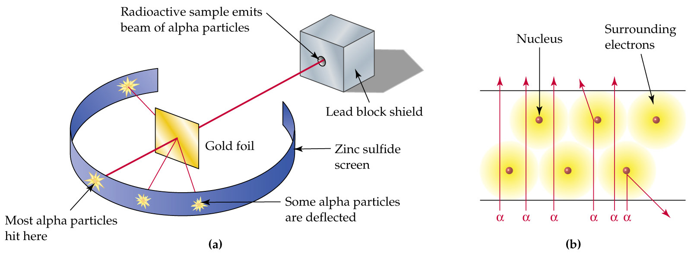
Rutherford's 'gold foil' experiment performed by Hans Geiger and Ernest Marsden using positively charged alpha particles:
- Most alpha particles passed ________ the gold foil suggesting that an atom is largely empty space.
- Some alpha particles were deflected significantly suggesting that the __________ charge of an atom must be concentrated in a very small sphere.
A very small number of alpha particles actually bounced back.

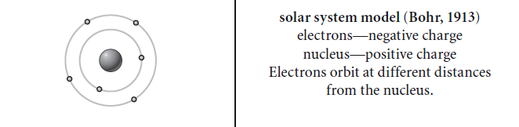
Neils Bohr (1913)
- Niels Bohr stated that electrons move in different ___________, or energy levels, around the nucleus like planets orbit the sun.
- An electron can ____________ energy and move to a higher energy orbit of larger radius. (________________ electrons)
- An excited electron can fall back to its original orbit by emitting energy as radiation.
- Electrons can only exist in certain discrete _______________ levels.
James Chadwick (1935)
- Chadwick discovered the ________________ which is a particle with no charge that is also located in the nucleus.
- Bombarded beryllium with __________ particles and discovered Rutherford's missing neutral particles.
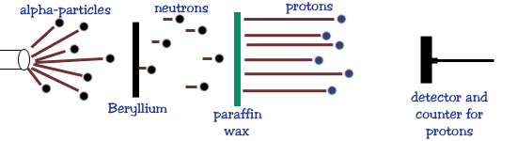
- Shared Nobel Prize for the discovery of the _____________________.
Frédéric Joliot and Irène Joliot-Curie (1935)
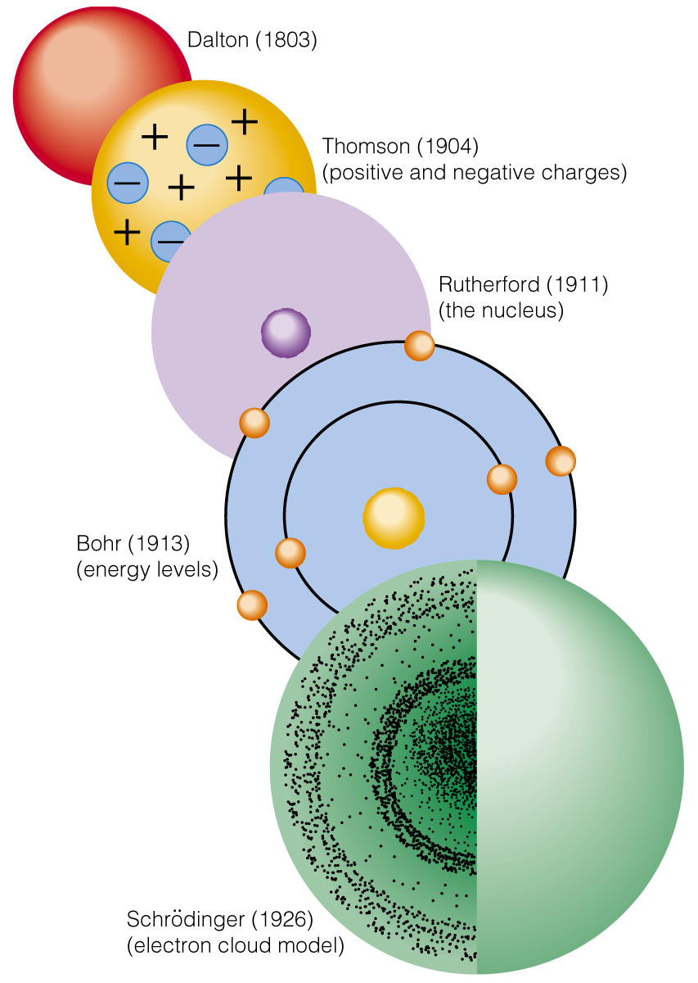
Frédéric Joliot and Irène Joliot-Curie worked on the _________________ of nuclei in 1934, which was an essential step in the discovery of the ________________.
