Make up

Pure Substances:

Every sample has same: ______________________________________ properties and _______________________________
Pure substances are made of: one type of atom or _______________________________
Ex: _________________________________________________
Pure substances are made of 2 or more types of atoms: ___________________________
Ex: ____________________________________________________
Which of the following models are pure substances? _____________________________

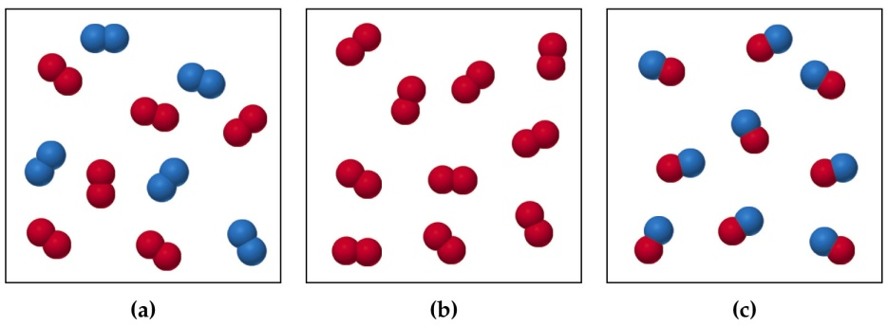

Mixtures:
Mixtures are a blend of _______________________ types of matter. Each component in the mixture keeps its own ___________________________ and ________________________
The components are only _____________________________________ mixed. Mixtures can be separated using _________________________
The properties of the mixture are a _____________________________of the _____________________________________ properties
Homogeneous Mixtures
are also called are _____________________; are uniform in ___________________________; and have no ___________________ parts. Ex: _________________________________________________
Heterogeneous Mixtures
are not uniform in _____________________ and have _______________
Ex: __________________________________________________
Physical Separation Techniques
_______________________________ - solid part is trapped by filter paper and the liquid part runs through the paper
_______________________________- where the liquid portion is evaporated off to leave solid
_______________________________ - when liquid is poured off after solid has settled to bottom
_______________________________- machine that spins a sample very quickly so that components with different densities will separate
_______________________________ - used to separate mixtures because different parts move quicker on paper than other.

