Nuclear Fission
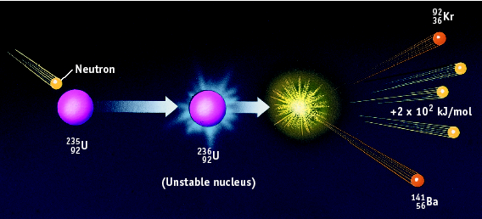
- Fission - ________ of a nucleus.
  - Very _______ nucleus is split into __ approximately ______ fragments.
  - _______ reaction releases several ________ which split more nuclei.
  - If controlled, ______ is released slowly (like in nuclear reactors). Reaction control depends on ________ the speed of the neutrons (_________ the reaction rate) and absorbing _______ neutrons (________ the reaction rate).
- Examples – atomic bomb, current nuclear power plants
  - ${}_{92}^{236}U$ → ${}_{56}^{141}{Ba}$ + ${}_{36}^{92}{Kr}$ + _____________

Nuclear Fusion
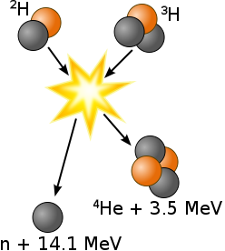
- Fusion - _________ of a nuclei
- Two light _______ combine to form a ________ heavier nucleus
- Does not occur under __________ conditions (+ repels +)
  - Advantages compared to _______
    - Inexpensive, No ___________ ______
  - Disadvantages
    - requires ______ amount of energy to ______, ________ to control
- Examples – energy output of stars, hydrogen bomb, future nuclear power plants
  - ${}_{1}^{2}H$ + ${}_{1}^{3}H$ → ${}_{2}^{4}{He}$ + neutron + ______________

Half-Life

- Half Life is the ____ required for ____ of a radioisotope’s ______ to decay into its _________.
  - For any radioisotope,

# of ½ lives | % Remaining
0 | 100%
1 | 50%
2 | 25%
3 | 12.5%
4 | 6.25%

- For example, suppose you have 10.0 grams of strontium – 90, which has a half life of 29 years. How much will be remaining after x number of years?
  - You can use a table:
  - Or an equation!

# of ½ lives | Time (Years) | Amount Remaining (g)
0 | 0 | 10
1 | 29 | 5
2 | 58 | 2.5
3 | 87 | 1.25

- Example 1: If gallium – 68 has a half-life of 68.3 minutes, how much of a 160.0 mg sample is left after 1 half life? ________ 2 half lives? __________

3 half lives? __________

- Iodine-131 is a radioactive isotope with a half-life of 8 days. How many grams of a 64 g sample of iodine-131 will remain at the end of 8 days? ________

- How many grams of a 64 g sample of iodine-131 will remain at the end of 32 days? ________

