**Temperature and Energy**

We relate energy and temperature by discussing a substance’s _______ _____________.

* + ­_________ _____________ = heat required to raise temp. of an object by 1oC
    - ______ heat is required to raise the temp. of a _______ sample of a substance by 1oC than is needed for a _________ sample
* Specific Heat Capacity
  + a ___________ property of matter that describes matter’s ____________ to a change in temperature. The symbol for specific heat is **____.**
    - Not all substances heat up at the same ______. Some get hot __________ and some more ______________.

Example

* 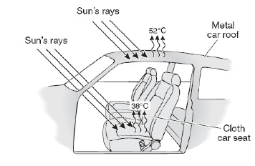If you have ever touched the metal on a car and the fabric on the car seat on a hot day, you have experienced the affect of specific heat. The metal seems much hotter than the fabric seat even if after receiving the same amount of energy from the sun. This is caused by the difference in the specific heat of each of the materials. The metal has a lower specific heat and gives up its thermal energy at a much higher rate than does the fabric which has a much higher specific heat.

**High Specific Heat and Water**

* Water has a very _____ _________ ______ compared to other matter; therefore ocean water stays about the ______ ___________ throughout day and night despite the differences in temperature between _______ and ______. That also explains why water is used in _____ _____________ to cool the engine.
  + **______ specific heat = ______ energy required to change the temperature**
  + **_______ specific heat = _______ energy required to change the temperature**

Which would get hotter if left in the sun?

* Penny vs. Water ● Plastic recycling bin vs. metal trash can
* Keys vs. soccer ball

**Specific Heat Capacity**

* Temperature change of a substance depends on three things:
  + ________, m
  + _______ ____ ________ _________, Q
  + ____________ _______, Cp

Write in formula

**Using ___________________________**

The following problems will show you how to solve for different variables in our equation.

* How much **energy** does it take to raise the temperature of 50 g of aluminum

(cp = 0.9025J/gC0) by 10 0C?

* If we add 30 J of heat to lead (cp = 0.1276J/gC0) with a mass of 10 g, how much will its **temperature** increase?