A Thermochemical Equation is a balanced ________________ chemical equation that includes the ___________ _______, ΔH.
- _____________ (H) is the transfer of _________ in a reaction (for chemical reactions it is in the form of ________) and ΔH is the change in ____________.
  - By definition, ΔH = Hproducts – Hreactants
        - Hproducts < Hreactants, ΔH is ___________
        - Hproducts > Hreactants, ΔH is ___________
- In working with thermochemical equations, you will find the following rules helpful.
  - When a thermochemical equation is multiplied by a ________, the value of H for the new equation is obtained by multiplying the ______ ___ __ by the same ___________.
  - When a chemical equation is ____________, the sign of H is ____________.
Writing Thermochemical Equations
- Thermochemical equations show the _____________ of heat in a chemical reaction.
  - For example, Burning one mole of wax releases __________ kJ of heat energy.
    - This could be written as:

    - Instead we usually write:

Practice
Write the following thermochemical equations showing ∆H.
- Reacting 2 moles of solid sodium with 2 moles of water to produce 2 mole of aqueous sodium hydroxide and 1 mole of hydrogen gas will release 367 kJ of energy

- 184.6 kJ of energy is needed to produce 1 mole of hydrogen gas and 1 mole of chlorine gas from 2 moles of hydrogen chloride gas.

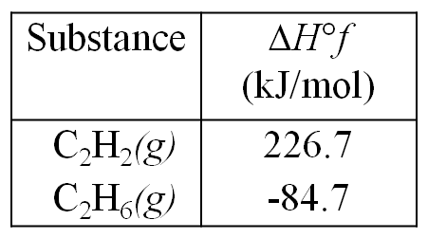
Thermochemical equations using Standard Heat of Formations
C₂H₂(g) + 2 H₂(g) → C₂H₆(g)
  - Information about the substances involved in the reaction represented above is summarized in the following tables.
  - Write the equation for the heat of formation of C₂H₆(g)

Solve for the ΔH_{rx} and write the following thermochemical equations.
- 1. What is the ΔH_{rx} for the process used to make lime (CaO)?
  - CaCO₃(s) → CaO(s) + CO₂(g)

- 2. What is the ΔHrx for the combustion of C4H10(g)?
  - 2 C4H10 (g) + 13 O2 (g) → 10 H2O (g) + 8 CO2 (g)

Thermochemical & Endothermic/ Exothermic equations
- In the previous slides, we saw how ______ could be both ___________ or ___________.
- Depending on the sign of ΔH°, the reaction can either be _______________ or _________________.
- ________________ reactions __________ heat from the system to the surroundings so the temperature will ______________.
  - ΔH° will be ___________because the reaction loses heat.
  - ΔH° can be written into the chemical equation as a _____________.
- ________________ reactions ___________ heat from the surroundings into the system so the temperature will ______________.
  - ΔH° will be ____________ because the reaction absorbs heat.
  - ΔH° can be written into the chemical equation as a _______________.
Classify the following as endothermic or exothermic
- Ice melting

- 2 C₄H₁₀(g) + 13 O₂(g) → 10 H₂O(g) + 8 CO₂(g) ΔH_{rx} = -5506.2 kJ/mol

- 2 HCl(g) + 184.6 kJ → H₂(g) + Cl₂(g)

- Water vapor condensing

Exothermic vs. Endothermic

