**Law of Conservation of Energy and Heat Transfer Notes**

1. 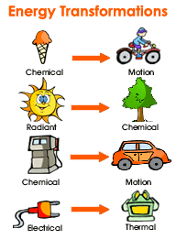Law of Conservation of Energy
   1. Also known as the _______________ of thermodynamics.
   2. **According to the law of conservation of energy, energy cannot be __________________________________.**
   3. It can only be transferred from one form to another.
2. Heat Energy
   1. The law of conservation of energy is also true of ___________________________.
   2. If a substance gets hotter something else must get colder.

**heatlost = heatgained**

1. Relating Temperature to Energy Transfer as Heat
   1. *__________________*,q, is energy that transfers from one object to another because of a temperature difference.
   2. The transfer of energy always takes place from a substance at a ______________ temperature to a substance at a ___________________
   3. temperature.
   4. Example : You are holding a hot water bottle what will happen:
      1. The warmer object (hot water bottle) will transfer energy to the cooler object (your hand).
      2. When energy is transferred as heat, the temperature of the water falls while the temperature of your skin rises.
      3. The great the difference in temperature of the two object, the more energy that will be transferred. This explains why hot things always cool down.
2. Let’s Look @ Temperature
   1. The internal energy or _____________________________ of a substance is determined by the movement of the molecules and the potential energy of the arrangement of molecules.
   2. **___________________**measures the average kinetic energy of the particles in a sample of matter

(Kinetic Energy = ½ mv2).

* 1. The greater the ____________________________ (the faster the molecules are moving), the higher the temperature, and the hotter it feels. When the kinetic energy decreases (molecules slow down), the temperature decreases.
  2. A substance can change in temperature due to __________________________.

1. Measuring Temperature
   1. *__________________________________________________* are device that is used to measure kinetic energy not temperature.
   2. Thermometers rely on a simple physical property of all substances
      1. MOST OBJECTS ___________________________ WHEN THEIR TEMPERATURE INCREASES
      2. Thermometers use liquids substance like mercury and colored alcohol that expand as their temperatures increase and contract as temperature decreases
2. 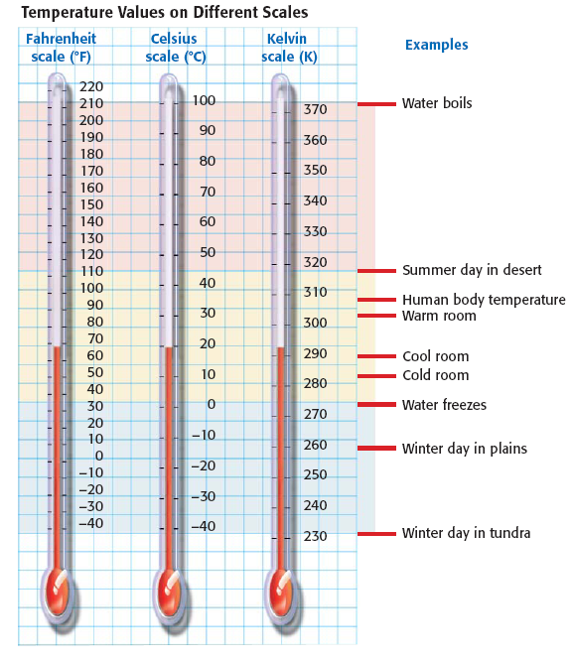Temperature Scales
   1. _____________________ Scale
      1. Most familiar to you from your friendly weather reports
      2. Units called DEGREES FAHRENHEIT [ °F]
      3. Water freezes at 32 °F and Boils at 212 °F
   2. ____________________ Scale
      1. Widely used in science and other countries
      2. Units called DEGREES CELSIUS [°C]
      3. Celsius scale is based the values of **0 °C** to freezing point of water and a value of 100 °C to boiling point of water (at standard pressure)
   3. _________________________ Scale
      1. Based on *absolute zero* the temperature at which an objects energy is minimal
      2. Units called KELVIN [K]
      3. On the Kelvin scale zero Kelvin is absolute zero
3. Methods of Energy Transfer
   1. _______________________ as heat from a hot object can occur in 3 ways
      1. Conduction
      2. Convection
      3. Radiation
   2. Heat transfer will stop when thermal _____________________________ is reached, that is the rate at which energy flows out of a substance equals the rate that energy flows into the substance.
4. 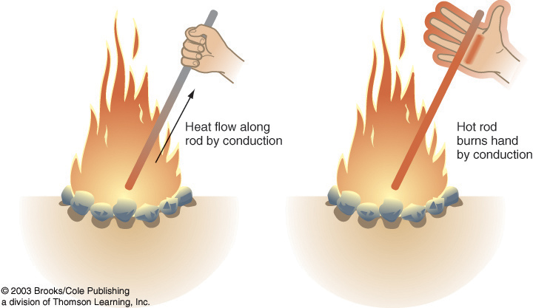Conduction
   1. The transfer of energy as heat between particles as they collide with a substance or between 2 objects in __________________
   2. Energy transfer through __________________
   3. Example: Heating marshmallows with a metal rod, as the marshmallow cook, the wire you are holding is getting hotter.
5. Convection
   1. The transfer of energy by the movement of ________________ with different temperature
   2. During convection, energy is carried away by a heated gas or liquids that expand and rises above cooler, denser gas or liquid
   3. **Energy transfer through** _______________________

**______________________________________**

* 1. The cycle of a heated fluid that rises and then cools and fall is called convection current

1. Radiation
   1. The transfer of energy by _________________________ waves
   2. **Energy transfer that** ___________________________

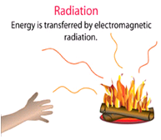**_______________________________________**

* 1. Example: You stand near the heat of the fire and feel the heat, energy is transferred as eat from the fire in this case in the form of electromagnetic waves
  2. Radiation differs from conduction and convection in that it does not involve the movement of matter

1. Review Main Points
   1. The law of conservation of energy: energy cannot be created or destroyed. It can only be transferred from one form to another.
   2. Heat is the transfer of energy from the particles of one object to those of another object due to temperature difference between the two objects.
   3. Also remember that, transfer of energy always takes place from a substance at a higher temperature to a substance at a lower temperature
   4. Three methods of energy transfer: conduction, convection and radiation