Unit 1: Dimensional Analysis Notes Date: ________
- Dimensional Analysis- is a problem-solving method that uses the idea that any number or expression can be multiplied by one without changing its value _____________ _____________ is used to convert one unit of measurement to another unit of measurement using ________________________________.
- Useful Conversions Factor: These Conversion Factors are __________ and unchanging relationships.
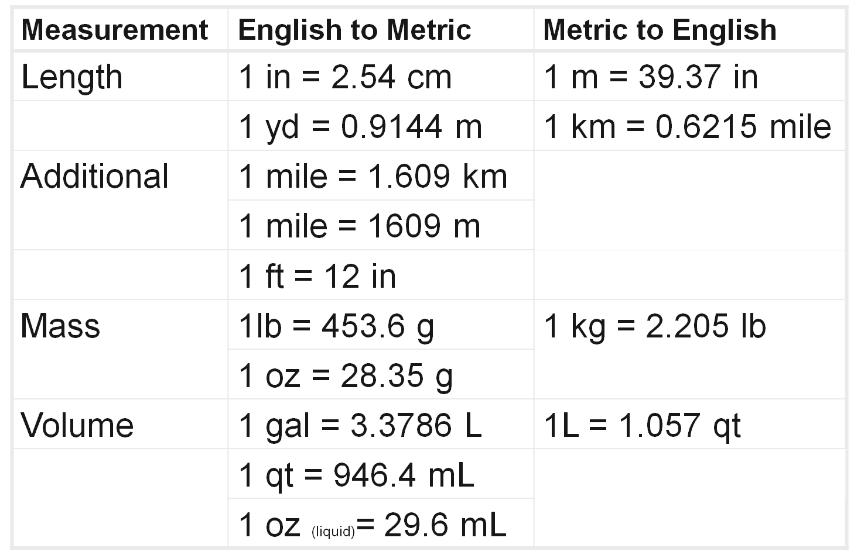
III. There are 5 Steps to do Dimensional Analysis?
1. Start with what value is ________, proceed to the unknown.
2. Draw the _________ _________ or fence (count the “jumps”).
3. Insert the _________ Factor.
4. _______ the units.
5. Do the ________, include units in answer.
IV. How do you set up a problem?
Using conversion factors and the following set up we can jump from unit to unit in a breeze!
Box #1  Write the value that _______ to be converted | Box # 3  One side of the  ____________ __________
Box #2  Write a ____ in the denominator | Box # 4  One side of the Conversion factor  (_______ ________ ___ ______ ____)
V. Examples
Example A: How many Slices there are in 7 Pizzas?
Given:____________
Want:____________
Conversion:________________

Example B: How old are you in days?
Given:____________
Want:____________
Conversion:________________

Example C: There are 2.54 cm in one inch. How many inches are in 17.3 cm?
Given:____________
Want:____________
Conversion:________________

