

This packet is property of:

________________________________________________________________________________

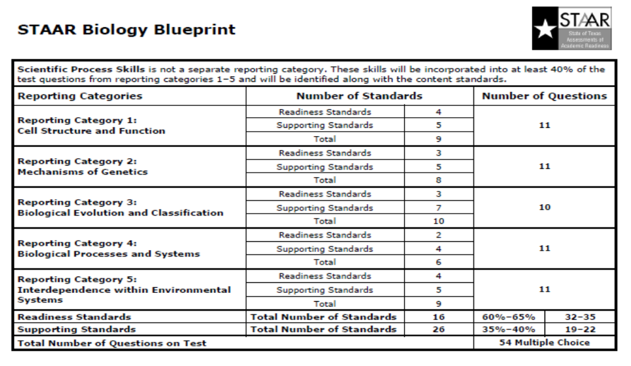
B.4.A: Compare and contrast prokaryotic & eukaryotic cells
1. Fill in this chart. Also give the letter or number of the part as seen in the diagrams below.
Cell Part and Letter | Structure Description | Function | Letter/Number
Nucleus

Plasma Membrane

Cell wall

Mitochondria

Chloroplasts

Ribosomes

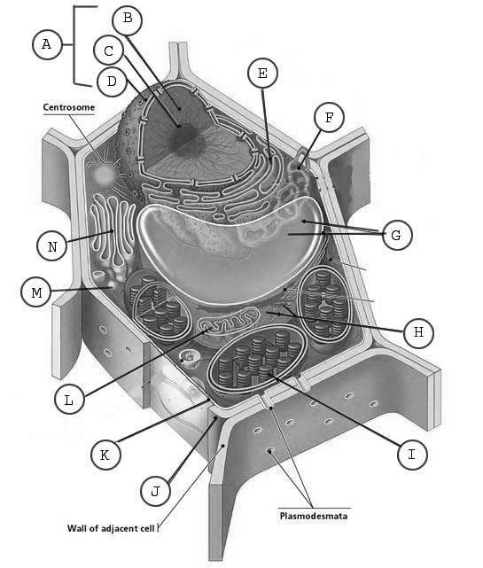
2. Which cell is the plant cell (left or right)? _____________________________

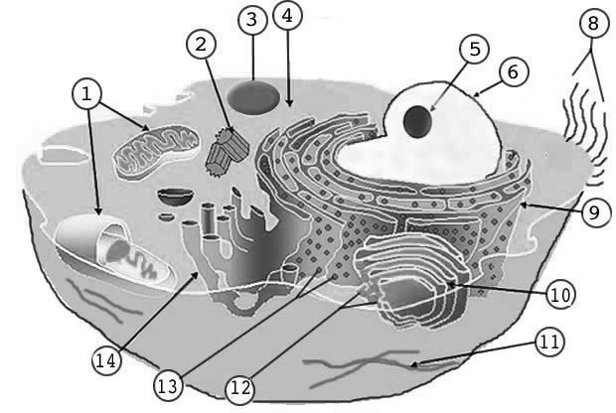
3. Which structures are found only in the plant cell?

__________________________

4. Which structures are found only in the animal cell?

__________________________

5. Compare the following two types of cells.
 | Prokaryotic | Eukaryotic
Membrane-bound organelles
Ribosomes
Types of chromosomes
Size

B.4.C Compare the structure of viruses to cells, describe viral reproduction, and describe the role of viruses in causing diseases such as human immunodeficiency virus (HIV) and influenza.

6. Describe the basic structure of a virus. What is it made of?

- Identify the following structures.
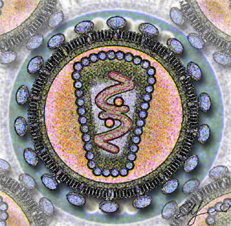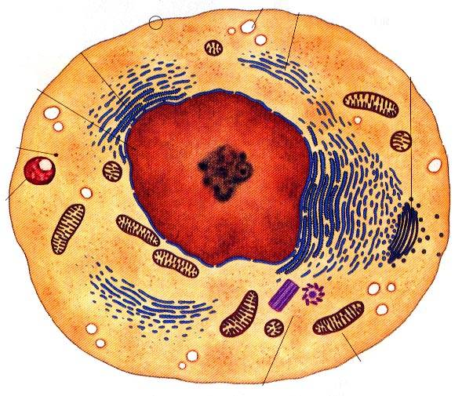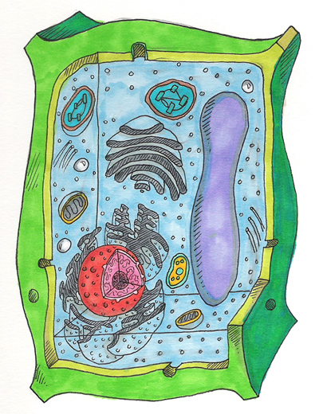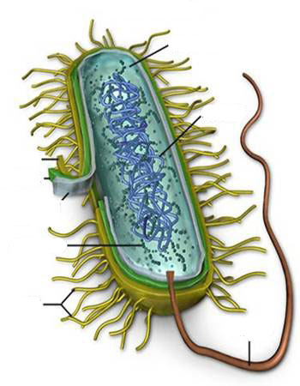
____________________ __________________ _____________ ______________

8. For the following diseases, give the agent and the symptoms.
 | Type of pathogen | Symptoms of Disease
HIV

Influenza

Smallpox

Streptococcus
(Strep Throat)
Viruses
Eukaryotes
Prokaryotes
9. Use the Venn Diagram to compare & Contrast Viruses and Cells.

- Arrange the following descriptions of viral reproduction in the correct order &

- Viral nucleic acid replicates using host cellular machinery.
- Virus attaches to a cell.
- New viral nucleic acids are packaged into viral particles and released from the cell. The host cell may be destroyed in the process.
- Virus penetrates cell membrane and injects nucleic acid into the cell.
______
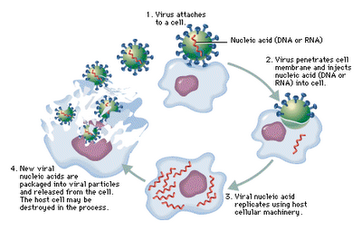

B.4.B Investigate and explain cellular processes, including homeostasis, energy conversions, transport of molecules, and synthesis of new molecules
The diagram shows many proteins and other molecules embedded in a cell membrane.
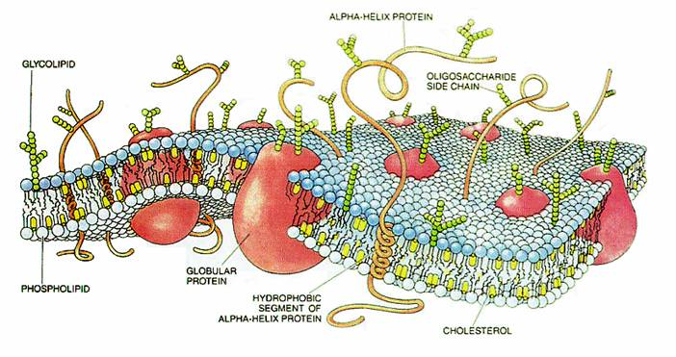
- What is the function of the cell membrane?

- What are some of the functions of these proteins and other molecules?

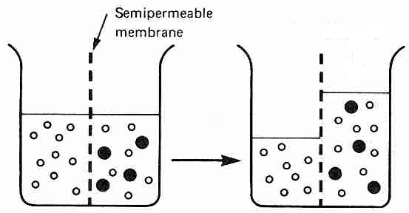
Explain what has happened in the diagram to the left.

13. Why did the large dark molecules NOT move to the left?

14. How is the semi-permeable membrane like a cell membrane?

15. If the dark molecule is starch, where is the starch concentration greatest (left or right)?

16. If the white molecule is water, where is the water concentration greatest at first?

17. In osmosis, water moves from an area of __________ to an area of _________ concentration. (higher/lower)

18. If the dark molecules could move, in what direction would they move? Why?

19. In diffusion, molecules move from an area of ________ to an area of ________ concentration. (higher/lower)

20. What is osmotic pressure?

21. Which way water will move in each of the following situations:
  - Salt inside the cell 65% and outside the cell 40%. ___________________________________
  - Sugar inside the cell 27% and outside 80%. ___________________________________

22. What is homeostasis?

23. How do cells maintain homeostasis? Consider pH, temperature, blood glucose, water balance

24. Comparison of active and passive transport
 | PASSIVE TRANPORT | ACTIVE TRANSPORT
Requires energy?

Low to high concentration or high to low concentration?
Examples

Energy use and release in biochemical reactions.
25. Use the following diagram to show where energy is released and where energy is used. Also use arrows on the lines attached to the circles to indicate the direction of the energy.
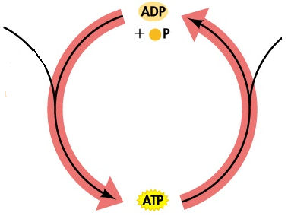
26. How many phosphates? ATP? _________ ADP? ________ AMP? _________

27. What cellular process produces ATP?

28. What is ATP energy used for? Give examples.

B.9.A Compare the structures and functions of different types of biomolecules, including carbohydrates, lipids, proteins, and nucleic acids

- What element makes all things “organic?” _________________________________

30. Compare and contrast the structure and functions of the following organic molecules:
Draw chemical structure
Macromolecules | Function | Subunits
Carbohydrates

Proteins

Lipids

Nucleic Acids

B.5.A Describe the stages of the cell cycle, including DNA replication and mitosis, and the importance of the cell cycle to the growth of organisms
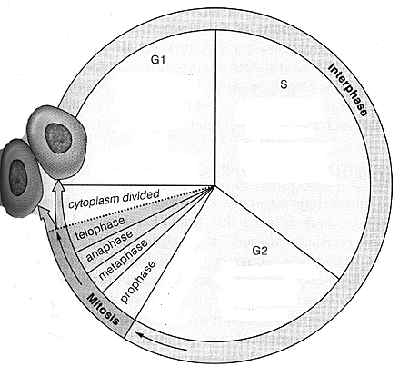
Cell Cycle

Look at the diagram of the cell cycle.
39. When does the replication of DNA occur? What is this phase called?

40. What do GI and G2 represent?

41. What stage does the cell spend most of its life in? ___________________
What does the cell do during this time?

42. Does mitosis include cytokinesis (division of the cytoplasm)? (Y/N?)

43. Put the following stages of mitosis (cell division) in order. Then Name them.

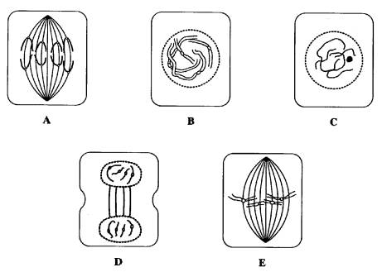
1st: ___________ called _____________________

2nd: ___________ called _____________________

3rd: ___________ called _____________________

4th: ___________ called _____________________

5th: ___________ called _____________________

- What is the importance of the cell cycle?

- When would cell division occur?
1.__________________________________
2.__________________________________
3.__________________________________

46. When would cell division cease?
1.__________________________________
2.__________________________________

Student Expectation | Did I Master this SE? | Student Grade | Date & Teacher Signature
B.4.B Investigate and explain cellular processes, including homeostasis, energy conversions, transport of molecules, and synthesis of new molecules

B.4.C Compare the structures of viruses to cells, describe viral reproduction, and describe the role of viruses in causing diseases such as human immunodeficiency virus (HIV) and influenza
B.5.A Describe the stages of the cell cycle, including DNA replication and mitosis, and the importance of the cell cycle to the growth of organisms
B.9.A Compare the structures and functions of different types of biomolecules, including carbohydrates, lipids, proteins, and nucleic acids
Additional Notes: | Students write in one of the following to indicate the level of their understanding in the space above:  I got it! I can do this without help.  I’m getting it! I’m beginning to understand and I can do it with some help.  I’m stuck. I don’t get it.

