Cell Reproduction

What is the role of DNA and RNA in protein synthesis?

Background information:

The genetic material of all living things is made of a molecule called deoxyribonucleic acid, or DNA. The traits of an organism are determined by the genetic code contained in its DNA.

Every cell in an organism´s body contains DNA which is unique to that organism. The DNA molecule is made up of two twisted strands of sugar and phosphate molecules attached to each other by nitrogen bases-adenine (A), guanine (G), cytosine (C), and thymine (T). Each “set” of one sugar, one phosphate, and one nitrogen base is called a nucleotide. The four nitrogen bases always bond in the following way: adenine pairs with thymine, and guanine pairs with cytosine. The pairs of nitrogen bases form bridges between the two strands of the DNA molecule. The sequence of the bases on the DNA molecule is an organism´s genetic code.

DNA contains the information for building amino acids. The order of nitrogen bases in DNA determines the type and order of amino acids in a protein. There are twenty different amino acids, but DNA contains only four types of bases. A sequence of three bases, called a triplet code, forms a code for a single amino acid.

Proteins are long chains of amino acids. Different proteins have different functions which determine the structure and function of an organism.

Ribosomes in the cytoplasm are sites where proteins are made. Because the genetic code for a protein is in the DNA in the nucleus of a cell, the code must be moved from the nucleus to the cytoplasm.

Before DNA moves from the nucleus to the cytoplasm, the code is transcribed into a
Messenger RNA (mRNA) molecule. The mRNA molecule is formed by free nitrogen bases attaching to nitrogen bases on an unwound segment of DNA. The nitrogen bases of RNA bond in the same way as in DNA except uracil (U) takes the place of thymine (T). Then the mRNA breaks away from the DNA and carries the genetic information to a ribosome in the cytoplasm.

The ribosome is where the genetic information in the mRNA is converted into a sequence of amino acids that make up a protein. This process is called translation. Transfer RNA (tRNA) brings amino acids to the ribosomes so they can be assembled into proteins. The nitrogen bases of the tRNA pair with the appropriate nitrogen bases of the mRNA. The amino acids on the tRNA bond to adjacent amino acids, break off from the tRNA, and form a protein molecule.

In this Virtual Lab you will build an mRNA molecule by pairing free nitrogen bases in the nucleus with nitrogen bases on an unwoven strand of DNA. Then you will examine how an mRNA molecule is translated into a protein molecule.

Objectives:
- Describe the structure and function of the DNA molecule.
- Explain how the genetic information in the DNA molecule is transcribed into mRNA.
- Explain how mRNA is translated into a specific sequence of amino acids in a protein molecule.

Procedure: FIRST – Prepare five (5) data tables like the one shown below….Then go to the website …..(BE SURE TO USE GOOGLE CHROME)

http://www.glencoe.com/sites/common_assets/science/virtual_labs/LS04/LS04.html

READ and follow all procedures…..

- Observe the unwoven DNA molecule. One of the DNA strands is exposed, showing a sequence of nitrogen bases.
- Record the DNA strand in your data table.
- Click the Legend button for information about how nitrogen bases pair.
- Build an mRNA molecule by pairing up free nitrogen bases in the nucleus with the nitrogen bases on the exposed strand of DNA. Start at the top where there is a blinking dot. Determine which free nitrogen base pairs up with the nitrogen base on the DNA. Drag a free nitrogen base to its corresponding nitrogen base on the DNA. If you chose the correct nitrogen base, the bases will bond. Continue pairing all of the bases.
- When you have finished building the mRNA molecule, watch the animation of the mRNA carrying the genetic information from the nucleus to a ribosome in the cytoplasm. As nitrogen bases on tRNA pair with nitrogen bases on mRNA, amino acids link together. A protein molecule is formed.
- Click the Show Labels button to see labels of the major structures involved in protein synthesis.
- Enter your data in the Table. Starting with the first amino acid in the protein molecule, record the amino acid number. Record the mRNA triplet code (three nitrogen bases) that corresponds to the amino acid. The mRNA triplet code for the first amino acid consists of the first three nitrogen bases on the mRNA molecule.
- Use the mRNA code to deduce the tRNA code. Remember that RNA is different from DNA in that it contains uracil (U) in place of thymine (T). Record your data in the Table.
- Use the data table of Amino Acid Classification to Determine the amino acids that make up the protein. Record them in your data table.
- Click the Reset button to synthesize another protein.
- Continue until you have synthesized five different proteins. (NOTE: these are randomly generated so you will NOT all have the exact same data)
- Answer the questions by filling in the blanks and writing complete sentences when describing or summarizing.
Data Tables: Prepare five separate tables – one for each of the five (5) proteins produced – Title each Table appropriately: Protein # 1, Protein # 2, etc.
Protein # 1
DNA Strand
mRNA
tRNA
Amino Acid #’s
Amino Acid Names

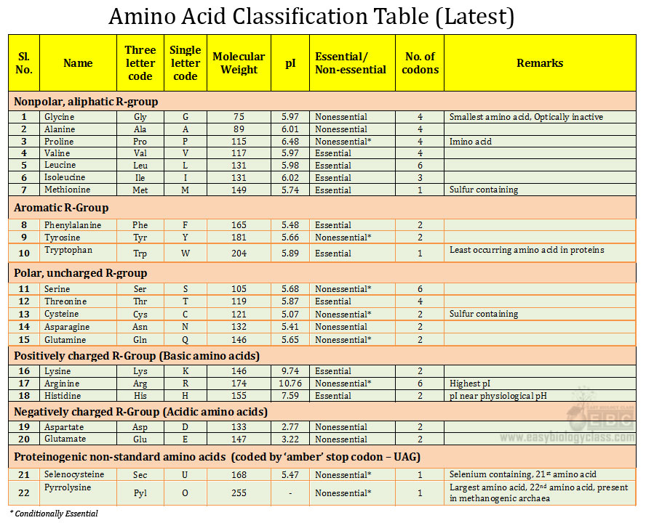

Answer the Analyze and Conclude Questions: (see background information)
- The traits of an organism are determined by the ___ ___ contained in its DNA.
- Describe the appearance and structure of DNA.
- What is a nucleotide?
- The four nitrogen bases always bond in the following way: adenine pairs with ___, and ____ pairs with cytosine.
- The sequence of the ____ in the DNA molecule is an organisms’ genetic code.
- What is the function of DNA?
- How many different amino acids are there?
- A sequence of three bases is called a/an ___ ___.
- Describe a protein molecule.
- In what part of the cell is a protein molecule made?
- What is the function of mRNA?
- In RNA, ___ takes the place of thymine.
- What is the function of tRNA?
- What is the process of translation?
- Why do you think there are equal amounts of cytosine and guanine and equal
amounts of adenine and thymine in the DNA of a cell?
- What might happen if there were an extra nitrogen base deleted from the mRNA
code?
- Summarize how DNA directs the making of a protein (In complete SENTENCES).

