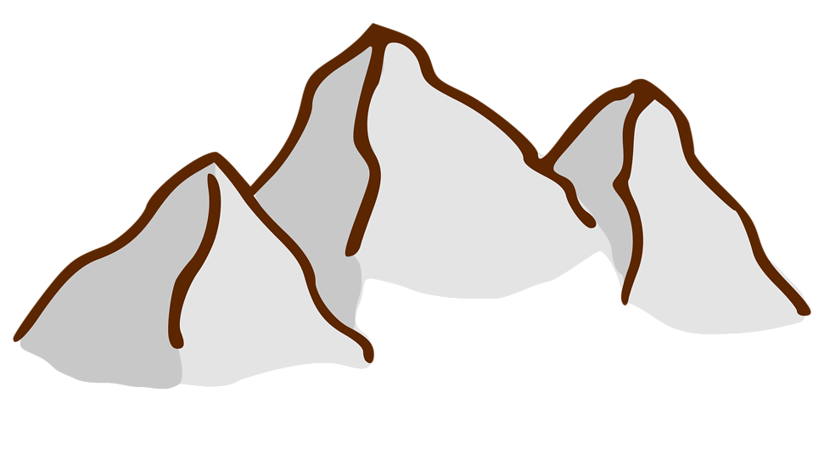
Internet Activity: Mountain Building

Part I
Click on the Website Link
http://www.nature.nps.gov/geology/tour/mountain.cfm
- Choose 2 links from each of the following categories in Park Geology Themes: “Tectonic Plates”
  - Convergent Plate Boundaries: Collisional Mountain Ranges - - Choose from Appalachian mountains, Ouachita, Marathon, or Brooks Range
  - Ocean-Continent Subduction Zone - - Choose from: Active Volcanic Arc-Cascades, Alaska, Ancient Arc Sierra Nevada, Accretionary Wedge -Coast Ranges, Low-angle Subduction-Laramide uplift
Read the information from each link.
- From the information gathered from the link, write a paragraph about the mountain park. Include as much information as you can about the age of the mountains and the heights of the mountains at each park. (That’s a total of 4 paragraphs, one for each link)
Part II
Click on the following link
https://geomaps.wr.usgs.gov/parks/province/rockymtn.html
Investigate the website and write a 1-page summary of the website describing how the Rocky Mountains were formed.
Part III
Visit the following links and write 3 sentences for each link giving specific facts or items of interest to you.
- https://www.thoughtco.com/k2-second-highest-mountain-in-world-755923
- https://www.livescience.com/40595-denali-mount-mckinley.html
- http://www.mounteverest.net/
- http://adventure.nationalgeographic.com/adventure/everest/

