INSIDE CANCER: Hallmarks of Cancer – Student Worksheet
http://www.insidecancer.org/
Part 2. MITOSIS PUZZLE
Objective: To identify the stages and events of mitosis (cell division) in a multicellular organism.
Background: Human embryos are similar in size to a rat embryo. Why then do they end up being such different sized organisms? The size of an organism is determined mostly by its number of cells and partially by the sizes of those cells. Certain cells in a human might be smaller than certain cells in a mouse and vice versa. In addition, most cells have a limit to the size they can grow. On the other hand fat cells can grow larger when we stores excess calories as fat droplets inside those cells. The more droplets, the larger the cell becomes until it reaches a point in which the control center (nucleus) can no longer manage a cell of that size. At that point the cell must undergo cell division.
In order for a cell to divide, it needs to make copies of the genetic code, cell organelles and other molecules necessary for each of the daughter cells to survive. After this point, the cell is ready to divide. The process of cell division occurs in a series of observable steps that scientists have termed “mitosis.” Below are some key players (organelles) in mitosis. Review their functions before going on.
- Chromosomes
- Chromatin
- Centrioles
- Nuclear membrane
- Cell Membrane
Directions: Through observation of the following stages of mitosis, one can figure out the most logical sequence of events. You know you are starting with one cell and ending with two. Use the information depicted in the pictures to place them in the correct order. Once you have the correct order (check with your teacher), cut each picture out and tape or glue onto a clean page in your science notebook. Then use the vocabulary words of the key players to write a complete caption for each picture of what is going on in the cell at that time.
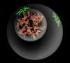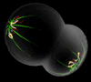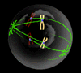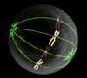

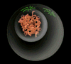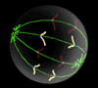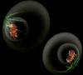
Pictures from: http://www.biology.arizona.edu/Cell_Bio/tutorials/cell_cycle/cells3.html

