Geologic Time Activity
Compare geologic time to the length of a football field, which is 100 yards long. Earth formed about 4.6 billion years ago. That's 4,600,000,000! If you divided 4.6 billion by 100, then each yard equals 46,000,000 years, and each ten yard section equals 460,000,000 years.
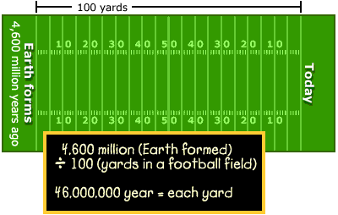
Making a Time Line
Print out or draw a model of a football field. (Note: The "print out" option provides you with a scale model of a 25-yard section of a football field and two end zones. You will need 4 copies of the 25-yard section but only 1 copy of the end zones.) Starting at the left (4.6 billion years ago) and "moving forward in time," label the 10-yard lines in years. Then, using different colored markers, draw a horizontal line to show the beginning and end of each of the following periods and eras.
- Cenozoic Era (65 million years ago [mya] to present)
- Triassic (245-208 mya), Jurassic (208-146 mya), and Cretaceous (146-65 mya) periods
- Paleozoic Era (570-245 mya)
- Proterozoic Era (2500-570 mya)
- Archaean Era (3800-2500 mya)
- Hadean Era (4600-3800 mya)
Option: Make a circle, pie diagram, or clock that shows the amount of time in degrees (there are 360 degrees in a circle) or in percentages for the following:
- a clock of the 4.6 billion year history
- a clock of the Mesozoic (Triassic, Jurassic, and Cretaceous)
- a clock of the Mesozoic to the present.
Additional Activities: What is a Million? and Finding an Event in Time

Finding an Event in Time
Many important events have occurred since Earth formed 4,600 million years ago (mya). Below is a list of some of those events. Your task is to mark on a time line when those events took place. If you haven't already done so, you might want to begin with the "Geologic Time Activity." That activity provides a scale model of a football field that can be used for this activity.
Mark the spot on the time line with an "X" where the following important events in Earth's history occurred.
- first microscopic life (3.6 bya)
- first multicellular life (900 mya)
- first oxygen appears in atmosphere (1.9 bya)
- first land plants appear (450 mya)
- formation of the Himalayas begins (30 mya)
- formation of the Atlantic Ocean begins (150 mya)
In the example below, we have used the football-field model for our time line. On it we have marked the first appearance of dinosaurs (225 mya), the disappearance of dinosaurs (65 mya), and the first appearance of homo sapiens (1/2 mya).
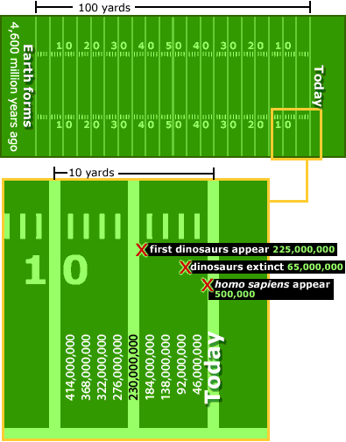
Option: As a group activity, it might be fun to create a geologic time line on the floor of your classroom or a hallway. First, you will need to measure the length of the place you have chosen to make your time line. Second, determine how many inches, feet, or yards represent a given number of years by dividing 4.6 billion by the length of your "time line."
To mark the events in Earth's history, you might prepare a sign representing each event and have students hold the signs and stand in the proper time spots on your geologic time line. (4.6 billion years is a big number to represent. To prevent the need for "student-markers" to stand on top of one another, you may want to use a very large space, such as a gym or a sidewalk for your time line.)

