Virtual Lab: Virtual Frog Dissection
Post-Lab Quiz and Lab Report

- If you come upon any terms that are unfamiliar to you, please refer to your textbook for further explanation or search the word here: http://encarta.msn.com/encnet/features/dictionary/dictionaryhome.aspx
- In this exercise, you will be performing a virtual frog dissection. To begin, click on the “Introduction” link on the opening page. Read through and listen to the information presented to learn about the basics of dissection and animal phylogeny. When you are finished, click the “Menu” button at the bottom of the page to return to the opening page of the laboratory activity.
- Once you are back to the opening page, click the “External Anatomy” button. Read through, watch and listen to the information presented in these segments. When you are finished, click the “Menu” button at the bottom of the page to return to the opening page of the laboratory activity.
- The last portion of this activity involves an examination of the internal anatomy of a frog. To do this, click the “Internal Anatomy” button on the opening page of the laboratory. Read through, watch and listen to all of the information presented in these segments and actively participate where required. You may have to do a virtual cut on the frog by dragging the appropriate tool to the frog or label organs of the dissected frog by dragging the appropriate organ names to the site on the opened frog. Please STOP when you are through with each labeling step and be sure to fill in your final answers on Figures 1 and 2 below.
- When you are through opening all of the segments in the “Internal Anatomy” section, you will have successfully completed the virtual dissection.
- Please finish this learning exercise by opening the “Journal” link at the bottom of the page and answering the questions.

Figure 1: Digestive System Organs
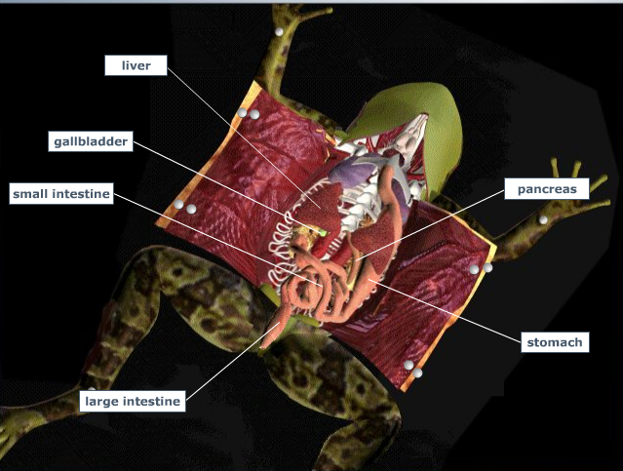

Figure 2: Organs of the Circulatory, Respiratory, Excretory and Reproductive Systems
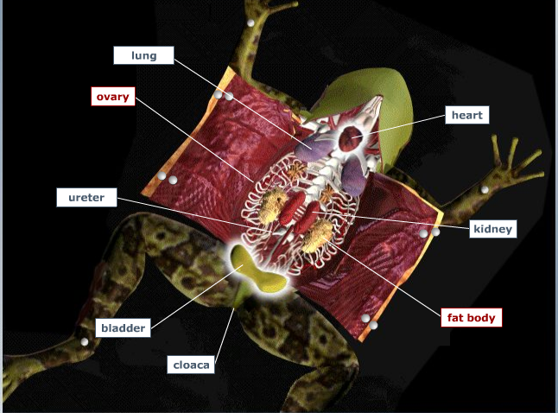

Post-laboratory Questions:

- The dorsal side of the leopard frog:
- Is a light, solid color
- Is a colored and patterned
- Is initially cut during a dissection
- A and C

- Leopard frogs:
- Are invertebrates
- Are warm-blooded
- Have a gills at one time during their life cycle
- All of the above

- In regards to the external anatomy of a leopard frog:
- It is easy to tell the sex of the animal
- The cloaca is at the anterior end of the animal
- The feet of the hind limbs have 5 toes
- All of the above

- In the opened mouth of the leopard frog, one can see:
- The nostrils
- The glottis
- The vomerine teeth
- A and B
- All of the above

- Which of the following is found in the digestive system of the leopard frog but not in that of a human?
- Gall bladder
- Stomach
- Pancreas
- Liver
- None of the above

- Arteries in the circulatory system:
- Carry blood to the heart
- Carry blood away from the heart
- Carry out diffusion of gases

- In the leopard frog heart:
- The right atrium carries oxygen rich blood
- The left atrium carries oxygen poor blood
- There are 3 chambers present
- All of the above

- By comparison to the leopard frog heart, the human heart:
- Has 4 chambers present
- Carries mixed blood in the ventricles
- Is more efficient
- A and C
- All of the above

- Fat bodies play a role in:
- Respiration
- Circulation
- Hibernation
- Reproduction
- C and D

- The most anterior portion of the leopard frog brain is/are the:
- Olfactory lobes
- Cerebrum
- Optic lobes

