Extra Credit 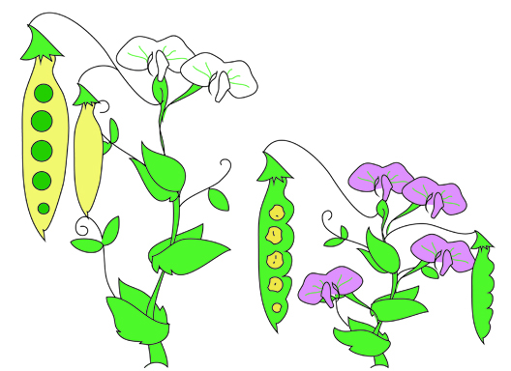
Super Giant Humongous Punnett Square
Mendel’s Seven Pea Plants’ Traits …..
Height Dominant Tall T
Recessive short t
Pea Shape Dominant Round R
Recessive wrinkled r
Pea Color Dominant Yellow Y
Recessive green y
Pod Shape Dominant Inflated I
Recessive constricted i
Pod Color Dominant Green G
Recessive yellow g
Flower color Dominant Purple P
Recessive white p
Location of Dominant Axial A
flower Recessive terminal a

Procedure
CROSS: Traits for Parent # 1 x Traits for Parent # 2
Height: homozygous dominant Height: heterozygous
Pea shape: heterozygous Pea shape: heterozygous
Pea color: homozygous recessive Pea color: homozygous recessive
Pod shape: homozygous dominant Pod shape: heterozygous
Pod color: heterozygous Pod color: homozygous dominant
Flower color: homozygous dominant Flower color: homozygous recessive
Location of flowers: heterozygous Location of flower: heterozygous

- Identify the “plant parents” genotypes
- Draw and complete a Punnett square
- Identify all possible genotypes WITH percentages
- Identify all possible phenotypes WITH percentages

