Drawing Atoms – Bohr Model 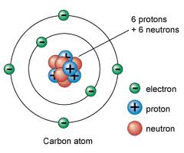
For each drawing:
- Write the element name and symbol
- Write the atomic number and atomic mass
- Write the number of
  - Protons
  - Neutrons (= mass number – atomic number)
  - Electrons
- Follow the rules for drawing Bohr models

Draw models for these elements:

- Fluorine
- Sodium
- Sulfur
- Calcium
- Phosphorous
- Chlorine
- Argon
- Aluminum
- Potassium
- Magnesium

