Codominance Worksheet for Cattle 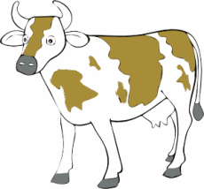
In shorthorn cattle, color shows incomplete dominance. A red cow has the genotype RR. A white cow has the genotype WW. Heterozygous cattle are called Roan (red and white spotted – and have a genotype of RW).
- Cross a red bull with a roan cow. SHOW the Punnett Square:
  - ____ % are Red
  - ____ % are Roan
  - ____ % are White
- Cross a roan bull with a roan cow. SHOW the Punnett Square:
  - ____ % are Red
  - ____ % are Roan
  - ____ % are White
- Cross a red bull with a red cow. SHOW the Punnett Square.
  - ____ % are Red
  - ____ % are Roan
  - ____ % are White
- Cross a white bull with a white cow. SHOW the Punnett Square.
  - ____ % are Red
  - ____ % are Roan
  - ____ % are White
- Cross a roan bull with a white cow. SHOW the Punnett Square.
  - ____ % are Red
  - ____ % are Roan
  - ____ % are White
- Cross a red bull with a white cow. SHOW the Punnett Square
  - ____ % are Red
  - ____ % are Roan
  - ____ % are White

Codominance Worksheet for Chickens 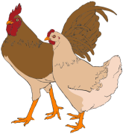
Andalusian chickens have one allele for white feathers and one allele for black feathers. Andalusian Chickens appear to have black and white checkered feathers (genotype BW). Where pure chickens are either black (BB) or white (WW)
- Cross two Andalusian Chickens. SHOW the Punnett Square:
  - ____ % are Black Chickens
  - ____ % are Andalusian Chickens
  - ____ % are White Chickens
- Cross an Andalusian rooster with a white hen. SHOW the Punnett Square:
  - ____ % are Black Chickens
  - ____ % are Andalusian Chickens
  - ____ % are White Chickens
- Cross a black rooster with a white hen. SHOW the Punnett Square:
  - ____ % are Black Chickens
  - ____ % are Andalusian Chickens
  - ____ % are White Chickens
- Cross a black rooster with an Andalusian hen. SHOW the Punnett Square:
  - ____ % are Black Chickens
  - ____ % are Andalusian Chickens
  - ____ % are White Chickens

