Earth/Space Science 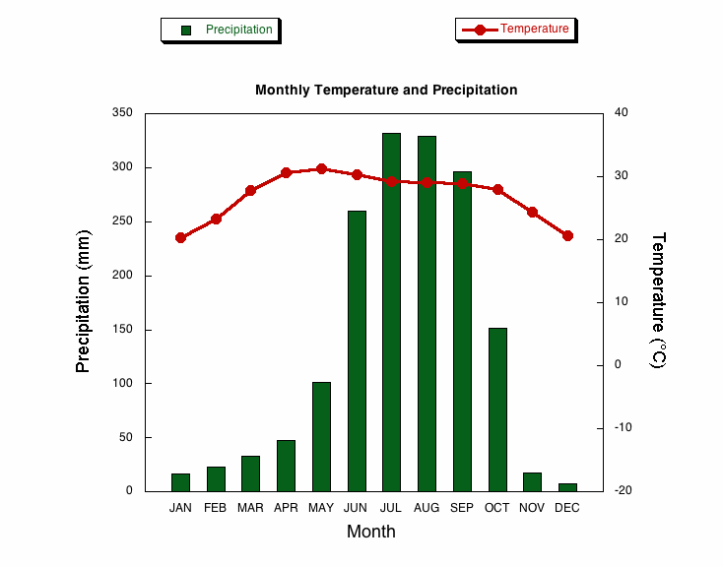
- Use the gold colored sheet as an example
- Make these climatographs
  - Banako/Senou, Mali
  - Tripoli City, Libya
  - Casablanca
  - El Paso, Texas, USA *data listed below
- There is blank paper for each graph
- Label the place at the top of each map
- Color the bar graphs (inches of rainfall) one color
- Draw colored line graphs (Temperature) a different color
- Answer questions (listed below) on a separate paper
- Staple all together
Questions:
After completing the climatograms, answer these questions:
- Which location has the lowest temperatures throughout the year?
- Which location has the most regular rainfall?
- Which has the most irregular rainfall pattern?
- Which two have the most similar patterns?
- Describe the similar patterns.
- Which two have the most different patterns?
- Describe those different patterns.
- How does El Paso weather compare to Bamako/Senou, Mali?
- How does El Paso weather compare to Tripoli City, Libya?
- How does El Paso weather compare to Casablanca?

*Data for El Paso Texas USA (rainfall in inches; temperature in Fahrenheit degrees [avg of high & low})
Month Jan Feb Mar Apr May June July Aug Sept Oct Nov Dec
Rain 0.40 0.47 0.26 0.23 0.47 0.94 1.55 2.01 1.51 0.61 0.49 0.78
Temp 45.5 50 56.5 65 74 82 83 81.5 75.7 65 53 45

