CLASSIFICATION – Extra Credit
Below are two examples of an organisms’ complete classification…….
Complete Classification of a Grizzly Bear Complete Classification of a Rose
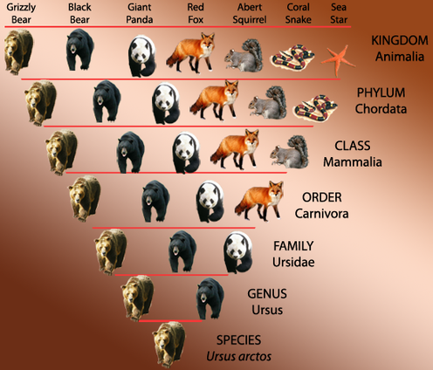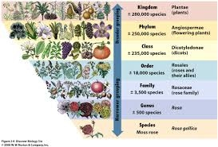
Grizzly Bear Classification: Moss Rose Classification:
Kingdom - Animalia Kingdom – Plantae
Phylum – Chordata Phylum – Angiosperms
Class - Mammalia Class - Dicotoyledonse
Order – Carnivora Order - Rosales
Family – Ursidae Family – Rosaceae
Genus – Ursus Genus - Rosa
Species – Ursus arctos Species – Rosa gallica

For an extra credit grade -------
- Choose any organism from any Kingdom
- Prepare a poster (FULL SIZE poster) with its complete classification
and comparative organisms at each level
- Include pictures and arrange like the samples above
- Write the complete classification for the organism

